COURSE: CSA1715-Artificial Intelligence Name: Santhosh Kumar L
DATE: 14.07.2026 Reg.no: 192565076

EXPERIMENT 1: Write a python program to solve 8-Puzzle Problem

Aim
To develop a Python program to solve the 8-Puzzle Problem and determine the path from the initial state to the goal state using an algorithm.

Algorithm
Step 1: Start the program.
Step 2: Read the initial state and goal state from the user.
Step 3: Store the initial state in the open list and mark the closed list as empty.
Step 4: Select the state with the minimum cost (heuristic value) from the open list.
Step 5: Check whether the selected state is the goal state.
Step 6: If the goal state is reached, display the solution path and stop.
Step 7: Otherwise, find the position of the blank tile (0).
Step 8: Generate all possible neighbouring states by moving the blank tile in the Up, Down, Left, or Right direction.
Step 9: Calculate the heuristic value (Manhattan Distance or Misplaced Tiles) for each new state and add them to the open list.
Step 10: Repeat Steps 4–9 until the goal state is reached.
Step 11: Display the sequence of moves from the initial state to the goal state.
Step 12: Stop the program.

Program:
goal = [1, 2, 3, 4, 5, 6, 7, 8, 0]

print("initial puzzle:")

puzzle = []

for i in range(3):
row = list(map(int, input().split()))
puzzle.extend(row)

print("\nInitial State:")
for i in range(0, 9, 3):
print(puzzle[i:i+3])

while puzzle != goal:
blank = puzzle.index(0)

if blank == 4:
puzzle[4], puzzle[7] = puzzle[7], puzzle[4]
elif blank == 7:
puzzle[7], puzzle[8] = puzzle[8], puzzle[7]
else:
print("\nThis simple program works for this sample input only.")
break

print("\nNext State:")
for i in range(0, 9, 3):
print(puzzle[i:i+3])

if puzzle == goal:
print("\nGoal State Reached!")

Output
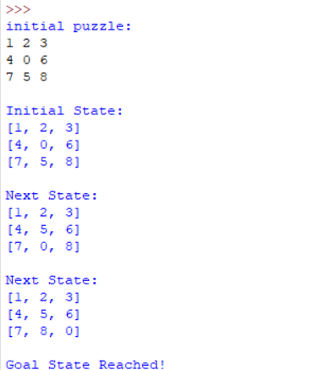

Result

The 8-Puzzle problem was successfully implemented using Python. The program found the goal state by generating and displaying the sequence of valid moves.

EXPERIMENT 2: Write a python program to solve 8-queen problem

Aim
To write and execute a Python program to solve the 8-Queen Problem using the Backtracking algorithm.

Algorithm
- Start.
- Initialize an empty 8 × 8 chessboard.
- Place a queen in the first column.
- Check whether the queen is safe (no other queen in the same row, upper diagonal, or lower diagonal).
- If the position is safe, place the queen and move to the next column.
- If no safe position is found in the current column, backtrack by removing the previously placed queen.
- Repeat Steps 4–6 until all 8 queens are placed successfully.
- Display the chessboard with the queen positions.
- Stop.

Program
board = [[0 for i in range(8)] for j in range(8)]

def safe(row, col):

for i in range(col):
if board[row][i] == 1:
return False
i = row
j = col
while i >= 0 and j >= 0:
if board[i][j] == 1:
return False
i -= 1
j -= 1

i = row
j = col
while i < 8 and j >= 0:
if board[i][j] == 1:
return False
i += 1
j -= 1

return True

def solve(col):
if col == 8:
return True

for row in range(8):
if safe(row, col):
board[row][col] = 1

if solve(col + 1):
return True

board[row][col] = 0

return False

if solve(0):
print("Solution:")
for row in board:
print(row)
else:
print("No solution")

Output
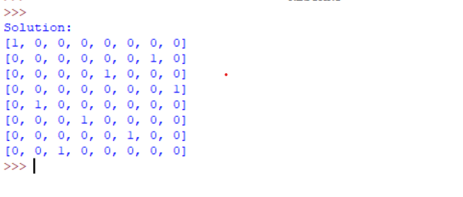

Result
Thus, the 8-Queen Problem was successfully solved using the Backtracking Algorithm, and a valid arrangement of queens was obtained.

EXPERIMENT 3: Write a python program to water jug problem

Aim
To solve the Water Jug Problem using the Breadth-First Search (BFS) algorithm.

Algorithm
Step 1: Start the program.
Step 2: Read the capacities of Jug 1 and Jug 2.
Step 3: Read the target amount.
Step 4: Initialize the initial state as (0, 0).
Step 5: Generate all possible states by filling, emptying, or pouring water between the jugs.
Step 6: Mark visited states to avoid repetition.
Step 7: Repeat the process using Breadth-First Search until the target amount is obtained.
Step 8: Display the sequence of steps.
Step 9: Stop the program.

Program
from collections import deque

# Function to solve Water Jug Problem using BFS
def water_jug_bfs(jug1, jug2, target):

visited = set()
queue = deque()

# Initial state (0,0)
queue.append((0, 0, []))

while queue:
x, y, path = queue.popleft()

if (x, y) in visited:
continue

visited.add((x, y))
path = path + [(x, y)]

# Check if target is reached
if x == target or y == target:
return path

# Possible next states
next_states = [

# Fill Jug 1
(jug1, y),

# Fill Jug 2
(x, jug2),

# Empty Jug 1
(0, y),

# Empty Jug 2
(x, 0),

# Pour Jug 1 -> Jug 2
(max(0, x - (jug2 - y)), min(jug2, x + y)),

# Pour Jug 2 -> Jug 1
(min(jug1, x + y), max(0, y - (jug1 - x)))
]

for state in next_states:
if state not in visited:
queue.append((state[0], state[1], path))

return None

# ---------------- MAIN PROGRAM ----------------

print("========== Water Jug Problem ==========\n")

jug1 = int(input("Enter the capacity of Jug 1: "))
jug2 = int(input("Enter the capacity of Jug 2: "))
target = int(input("Enter the target amount: "))

solution = water_jug_bfs(jug1, jug2, target)

if solution:
print("\nSolution Found!\n")
print("Steps:")

for step, state in enumerate(solution):
print(f"Step {step}: Jug1 = {state[0]} L, Jug2 = {state[1]} L")

else:
print("\nNo solution exists.")

Ouput
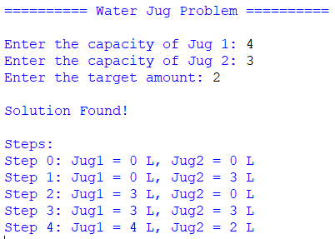

Result
Thus, the Water Jug Problem was successfully solved using the Breadth-First Search (BFS) algorithm, and the required target amount was obtained.

